**HOW TO CREATE A DIRECTORY ON LOCAL MACHINE AND PUSH THE CHANGES FROM LOCAL MACHINE**

* Create a directory

* Verification process

* Make it gitrepo

* I pasted files into the directory on local machine

* **Before making any changes change the branch name from master to main**

* Add files and commit



* Add the origin

* **Check the origin**

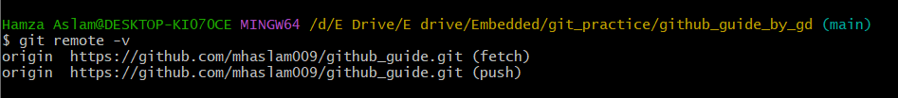

* **PUSH THE CHANGES**

* **Verify on your github repo**

* To add further pushes

